CSA1505 - CLOUD COMPUTING AND BIG DATA ANALYTICS
Experiment-6
- Create a simple cloud software application for Payroll Processing System using any Cloud Service Provider to demonstrate SaaS include the necessary fields such as Name of the employee, experience in present org , over all experience, basic pay, HRA, DA, TA, net pay, gross pay etc.

AIM:
To develop a simple Employee Salary Management System using Zoho Creator (Cloud Service Provider) to demonstrate the Software as a Service (SaaS) model. The application calculates the employee's gross salary and net salary based on salary components and deductions.
PROCEDURE:
Log in to Zoho Creator.
Create a new application named Employee Salary Management System.
Design a form with the following fields:
- Employee Name
- Employee ID
- Basic Salary
- Dearness Allowance (DA)
- House Rent Allowance (HRA)
- City Compensatory Allowance (CCA)
- Performance Compensation (PC)
- Tax
- Gross Salary
- Net Salary
- Last Update
Create workflows to:
- Calculate Gross Salary = Basic Salary + DA + HRA + CCA + PC.
- Calculate Net Salary = Gross Salary − Tax.
- Automatically update Last Update with the current date and time.
Save and publish the application.
Enter sample employee salary details.
Verify that the salary calculations and automatic updates are performed correctly.
INPUT:
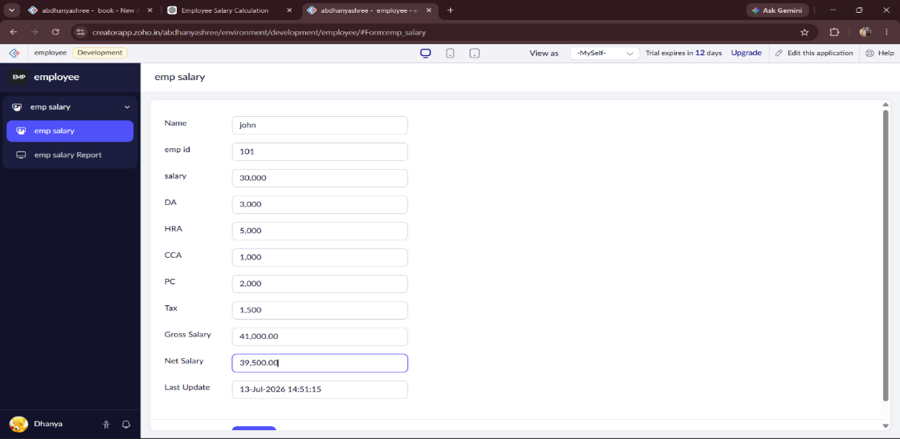
OUTPUT:
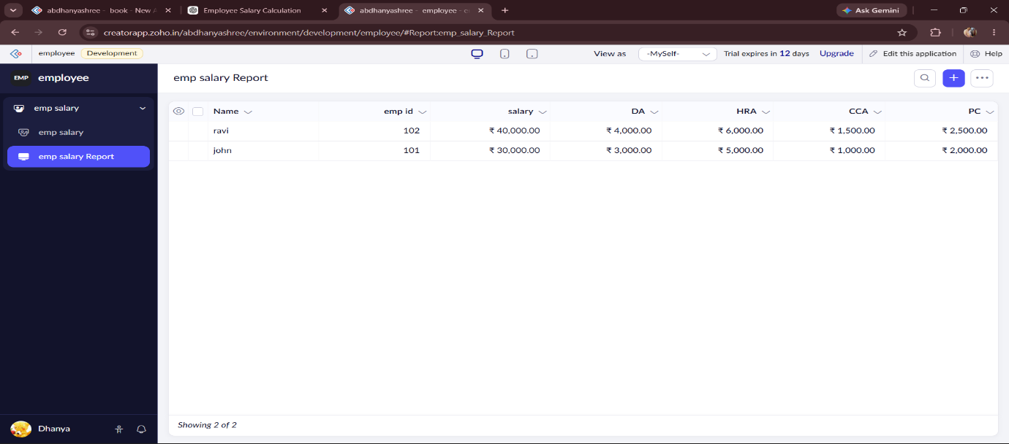

DESIGN:
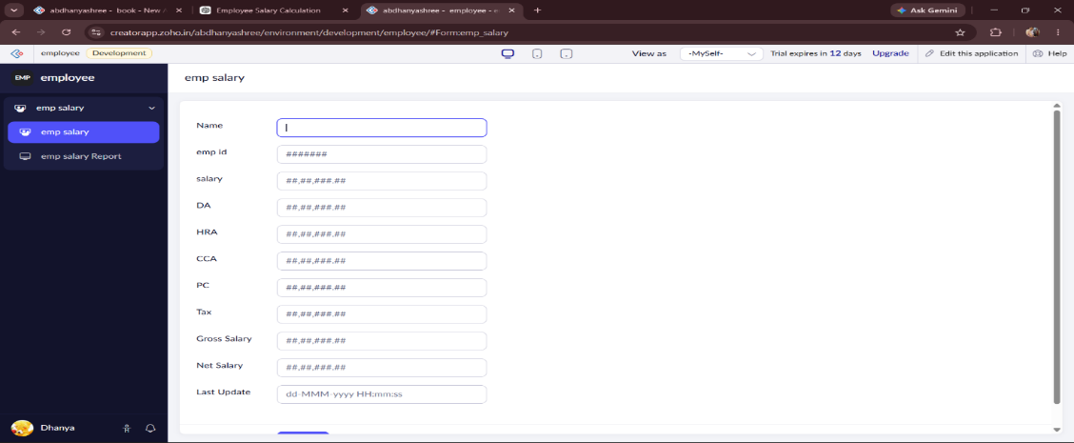

WORKFLOW:
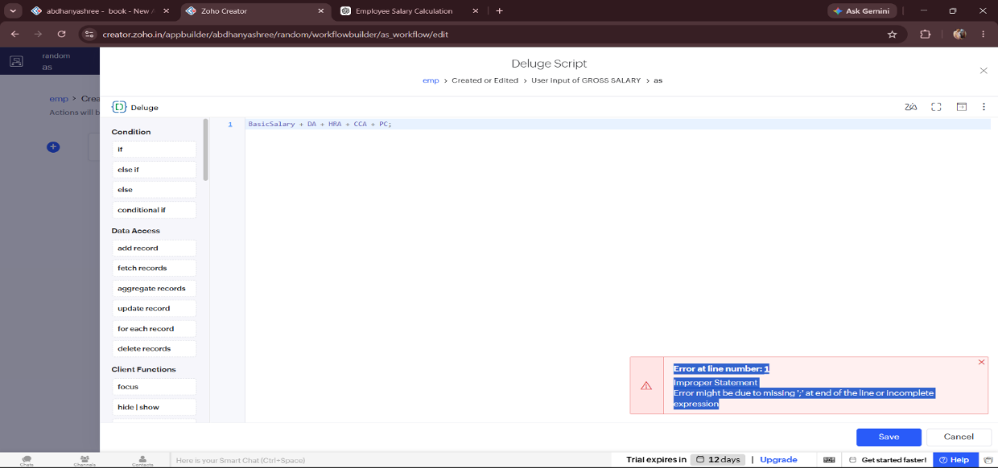

RESULT:
A cloud-based Employee Salary Management System was successfully developed using Zoho Creator. The application stores employee salary details, automatically calculates gross salary and net salary, and updates the last modified date. This demonstrates the Software as a Service (SaaS) model using a cloud platform.

